**بنھا**

**جامعة**

**بشبرا**

**الھندسة**

**كلية**

**الجامعي**

**العام**

**٢٠١٩**

**-**

**٢٠٢٠**



Name: Mohamed Nasr Eid Ahmed Ibrahim

B.N/

Date:31/5/2020

## Email Github:

Github page:

**بنھا**

**جامعة**

**بشبرا**

**الھندسة**

**كلية**

**الجامعي**

**العام**

**٢٠١٩**

**-**

**٢٠٢٠**



Application Brief:-

Computer architecture is a design and architecture for the functional processes of a computer system.

The computer architecture is the functional fingerprint of all requirements and design, and also the application of parts

From a different computer, as it focuses on some foundations by completing the CPU

 Internally for all tasks and also for how it communicates with memory addresses, inside computer memory and also knowledge

The science is under computer organization

computer definition:-

**A programmable electronic device designed to accept data And do the mathAnd rationalization set at high speed and display results These operations. Large computers and computers are consideredDesktop and portable Tablets and smartphones are some of Types of computers Different**

computer history:-

## mathematics teacher Charles Babbage appeared in the ninth century Ten design analytical engine The base framework for computers right Now:-

## 1- First generation (1937-1946): the first electronic computer "Atan a soff-Berry"

## 2- Second generation (1947-1962): using a transistor, and the first computer was introduced in 1951 (uniuac 1) In 1953

## 3- Third generation (1963: now): the integrated circuit was invented, devices became smaller and more powerful (Operating System Born (Dos-Ms)-Company (MS)-WINDOWS)

Types of computer:-

1. **Personal computer: - Small, individual, dependent on microprocessors**
2. **Workstations:-Powerful, single user, more powerful processors**
3. **Small computer:-multi-user, support hundreds at one time**
4. **Central Computer:-Powerful multi-user, supporting hundreds or thousands of users at one time**
5. **The supercomputer:-extremely fast that can execute hundreds of millions of instructions on the screen**

computer component:-

# 1- Motherboard unit

# 2- CPU

# 3- main memory

# 4-Hard Disk

# 5- CD player

# 6- Data carriers

# 7- Hardware cards

# 8- Input and output units

**بنھا**

**جامعة**

**بشبرا**

**الھندسة**

**كلية**

**الجامعي**

**العام**

**٢٠١٩**

**-**

**٢٠٢٠**



Home page:- 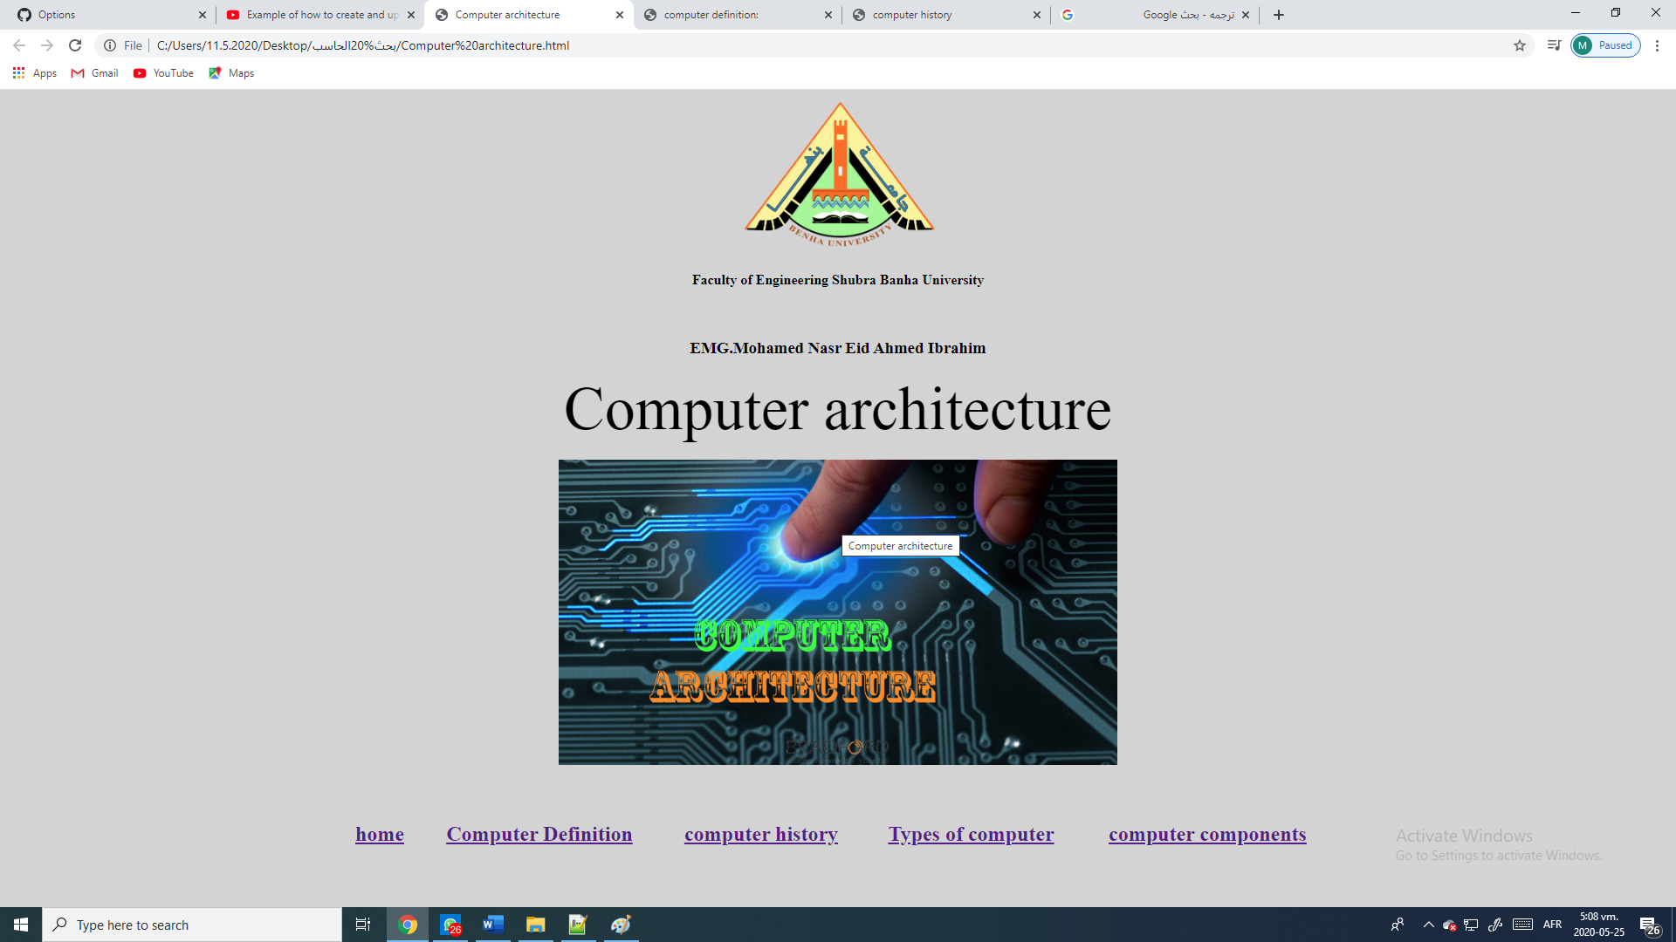

Source code:-

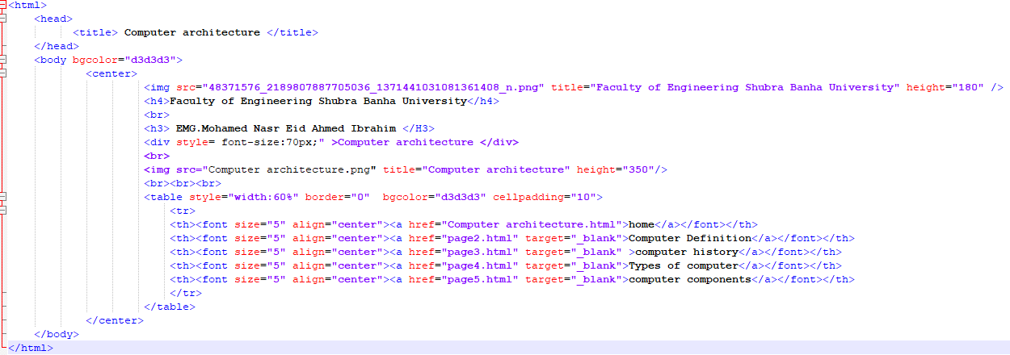

**بنھا**

**جامعة**

**بشبرا**

**الھندسة**

**كلية**

**الجامعي**

**العام**

**٢٠١٩**

**-**

**٢٠٢٠**



Page2:- 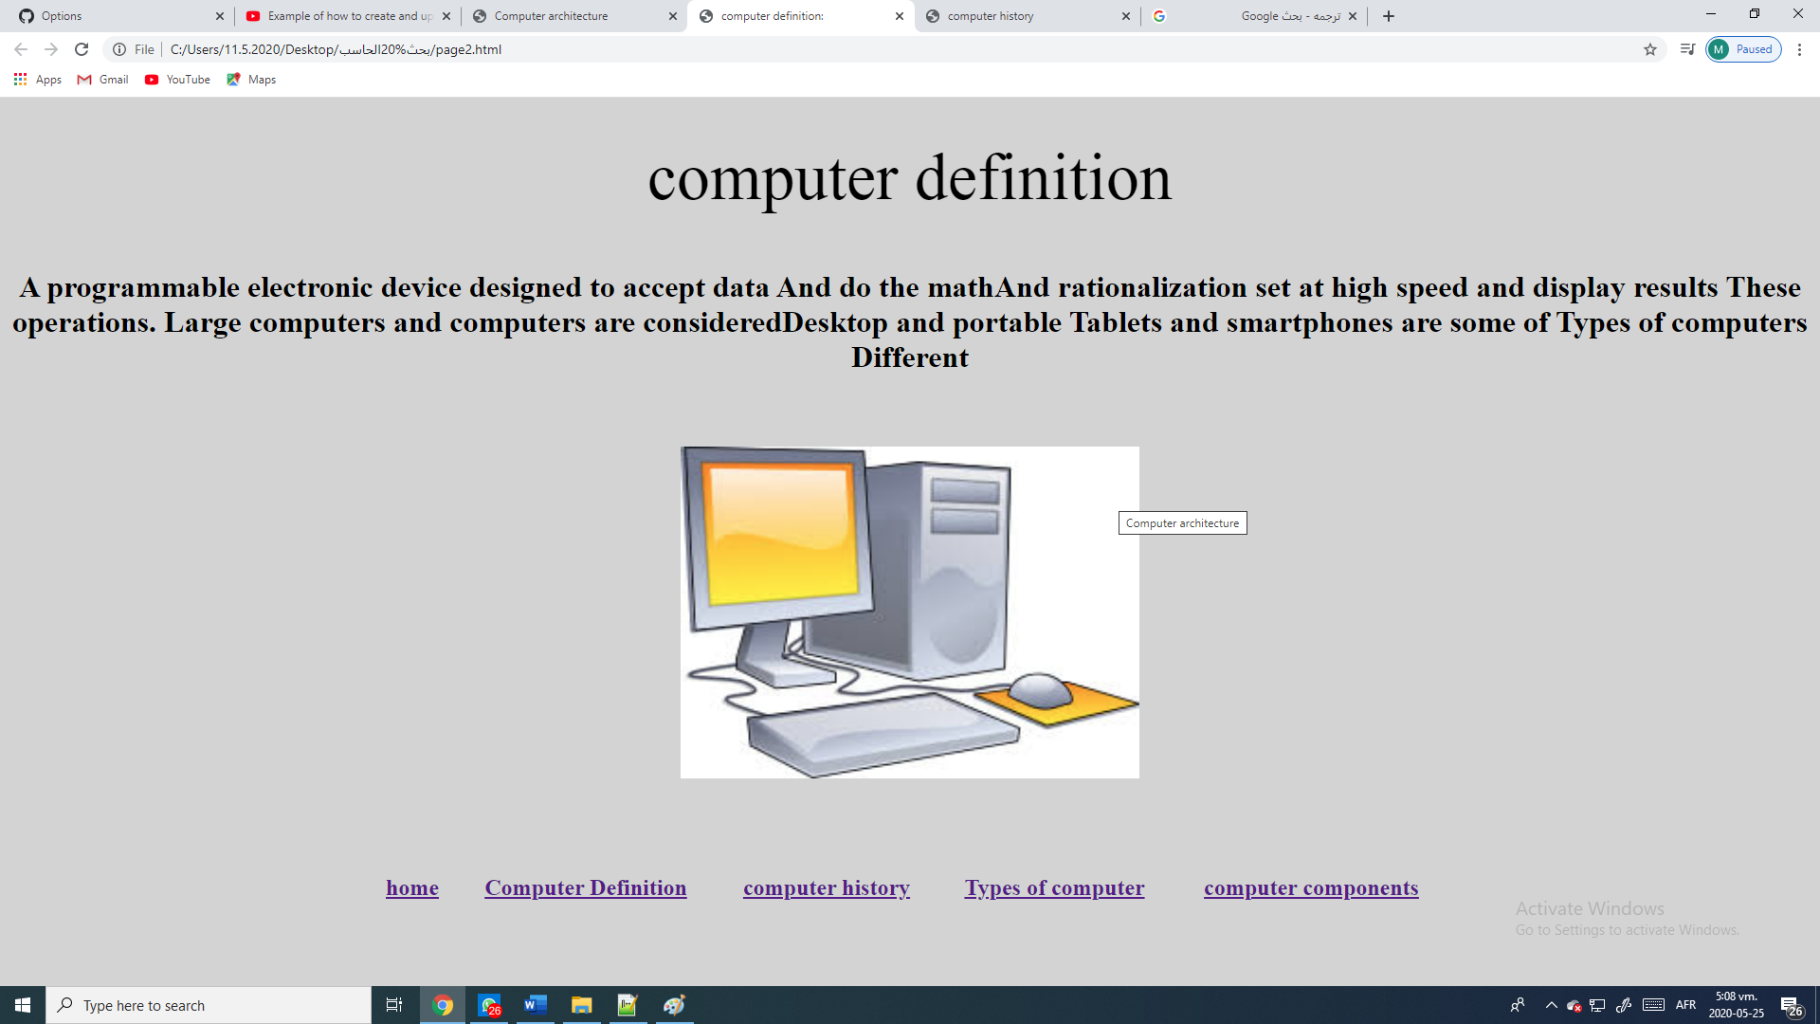

Source code:-

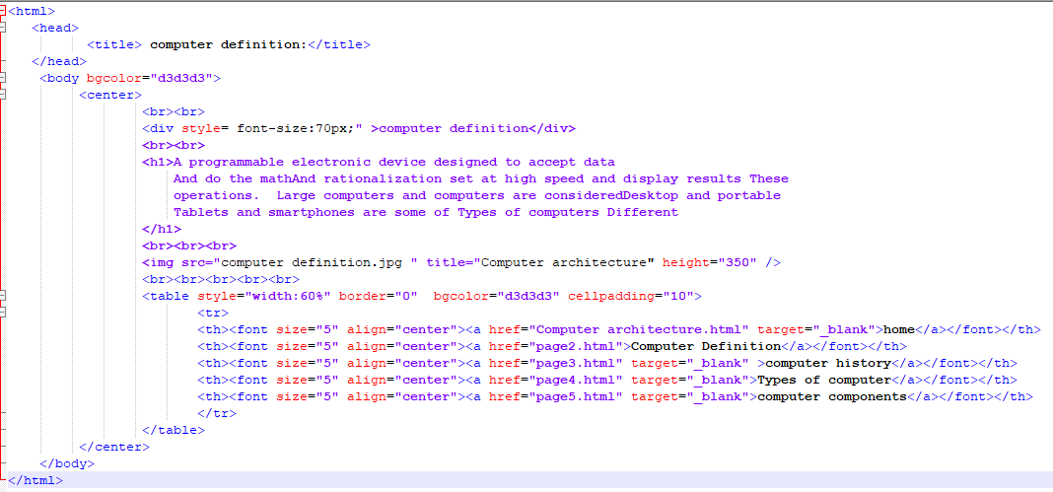

**بنھا**

**جامعة**

**بشبرا**

**الھندسة**

**كلية**

**الجامعي**

**العام**

**٢٠١٩**

**-**

**٢٠٢٠**



**بنھا**

**جامعة**

**بشبرا**

**الھندسة**

**كلية**

**الجامعي**

**العام**

**٢٠١٩**

**-**

**٢٠٢٠**



**بنھا**

**جامعة**

**بشبرا**

**الھندسة**

**كلية**

**الجامعي**

**العام**

**٢٠١٩**

**-**

**٢٠٢٠**



Page3:-

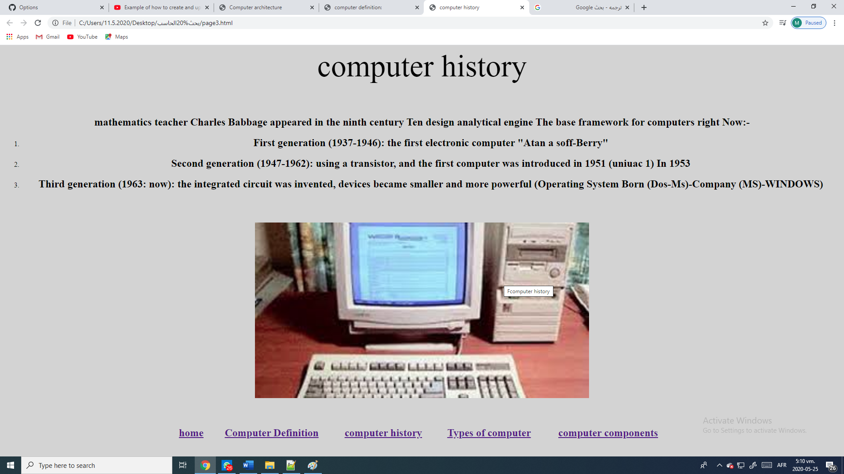

Source code:-

**بنھا**

**جامعة**

**بشبرا**

**الھندسة**

**كلية**

**الجامعي**

**العام**

**٢٠١٩**

**-**

**٢٠٢٠**



**بنھا**

**جامعة**

**بشبرا**

**الھندسة**

**كلية**

**الجامعي**

**العام**

**٢٠١٩**

**-**

**٢٠٢٠**



**بنھا**

**جامعة**

**بشبرا**

**الھندسة**

**كلية**

**الجامعي**

**العام**

**٢٠١٩**

**-**

**٢٠٢٠**



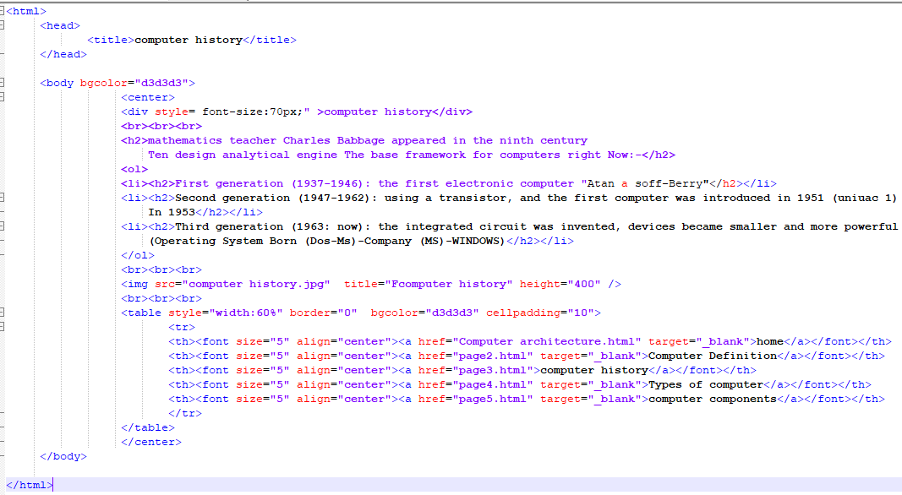

**بنھا**

**جامعة**

**بشبرا**

**الھندسة**

**كلية**

**الجامعي**

**العام**

**٢٠١٩**

**-**

**٢٠٢٠**



Page4:-

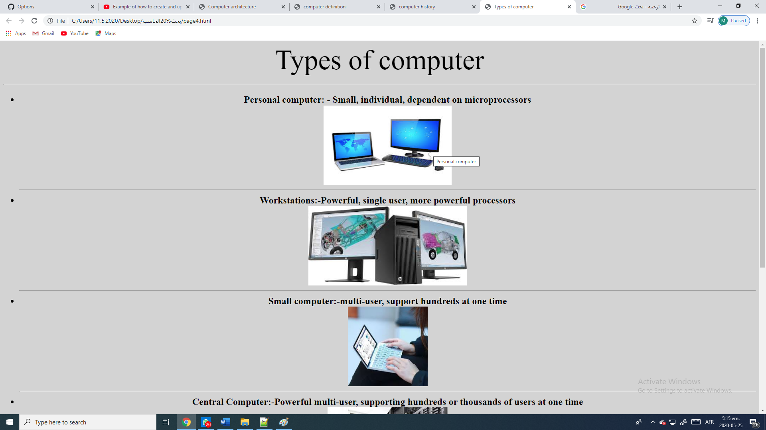

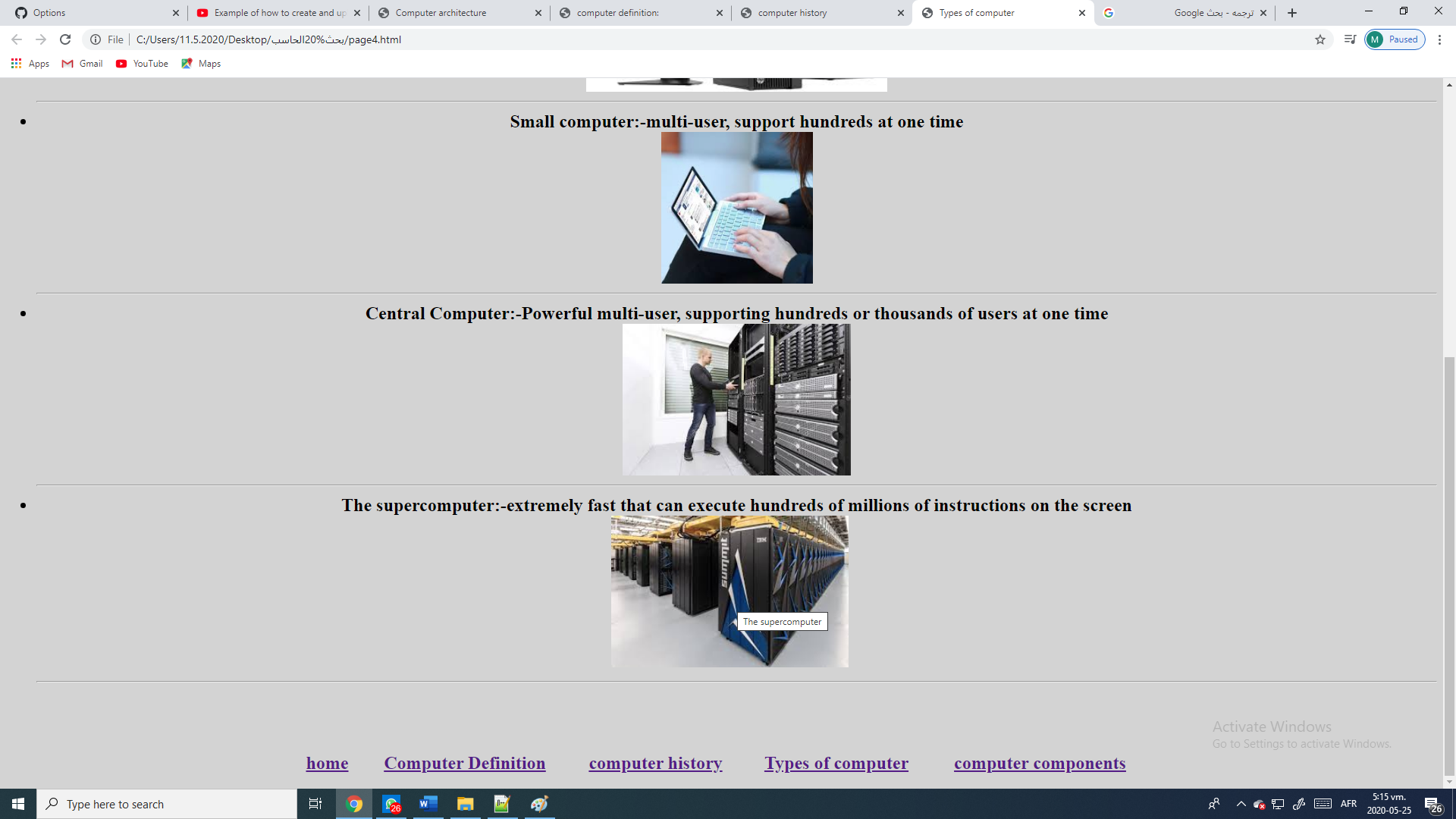

Source code:-

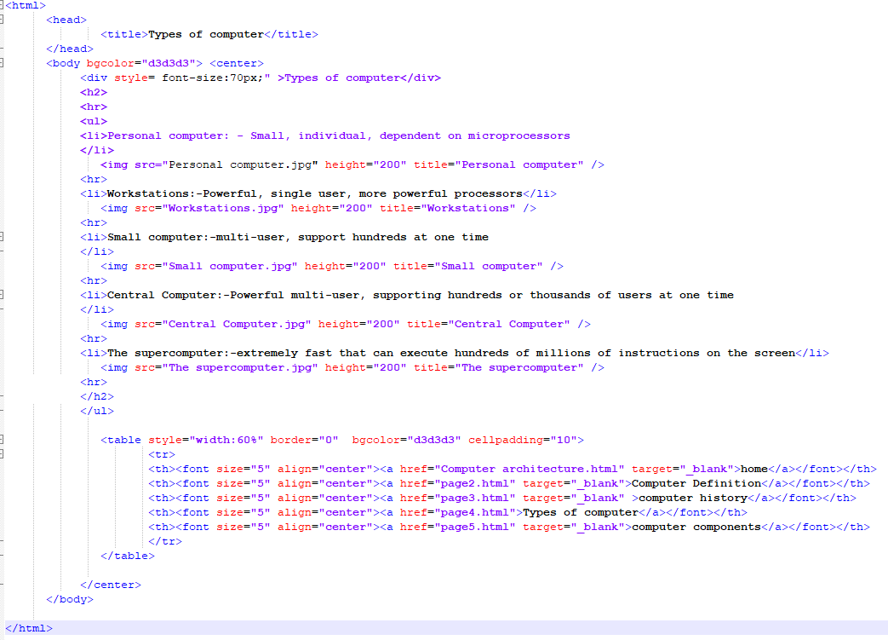

**بنھا**

**جامعة**

**بشبرا**

**الھندسة**

**كلية**

**الجامعي**

**العام**

**٢٠١٩**

**-**

**٢٠٢٠**



Page5:-

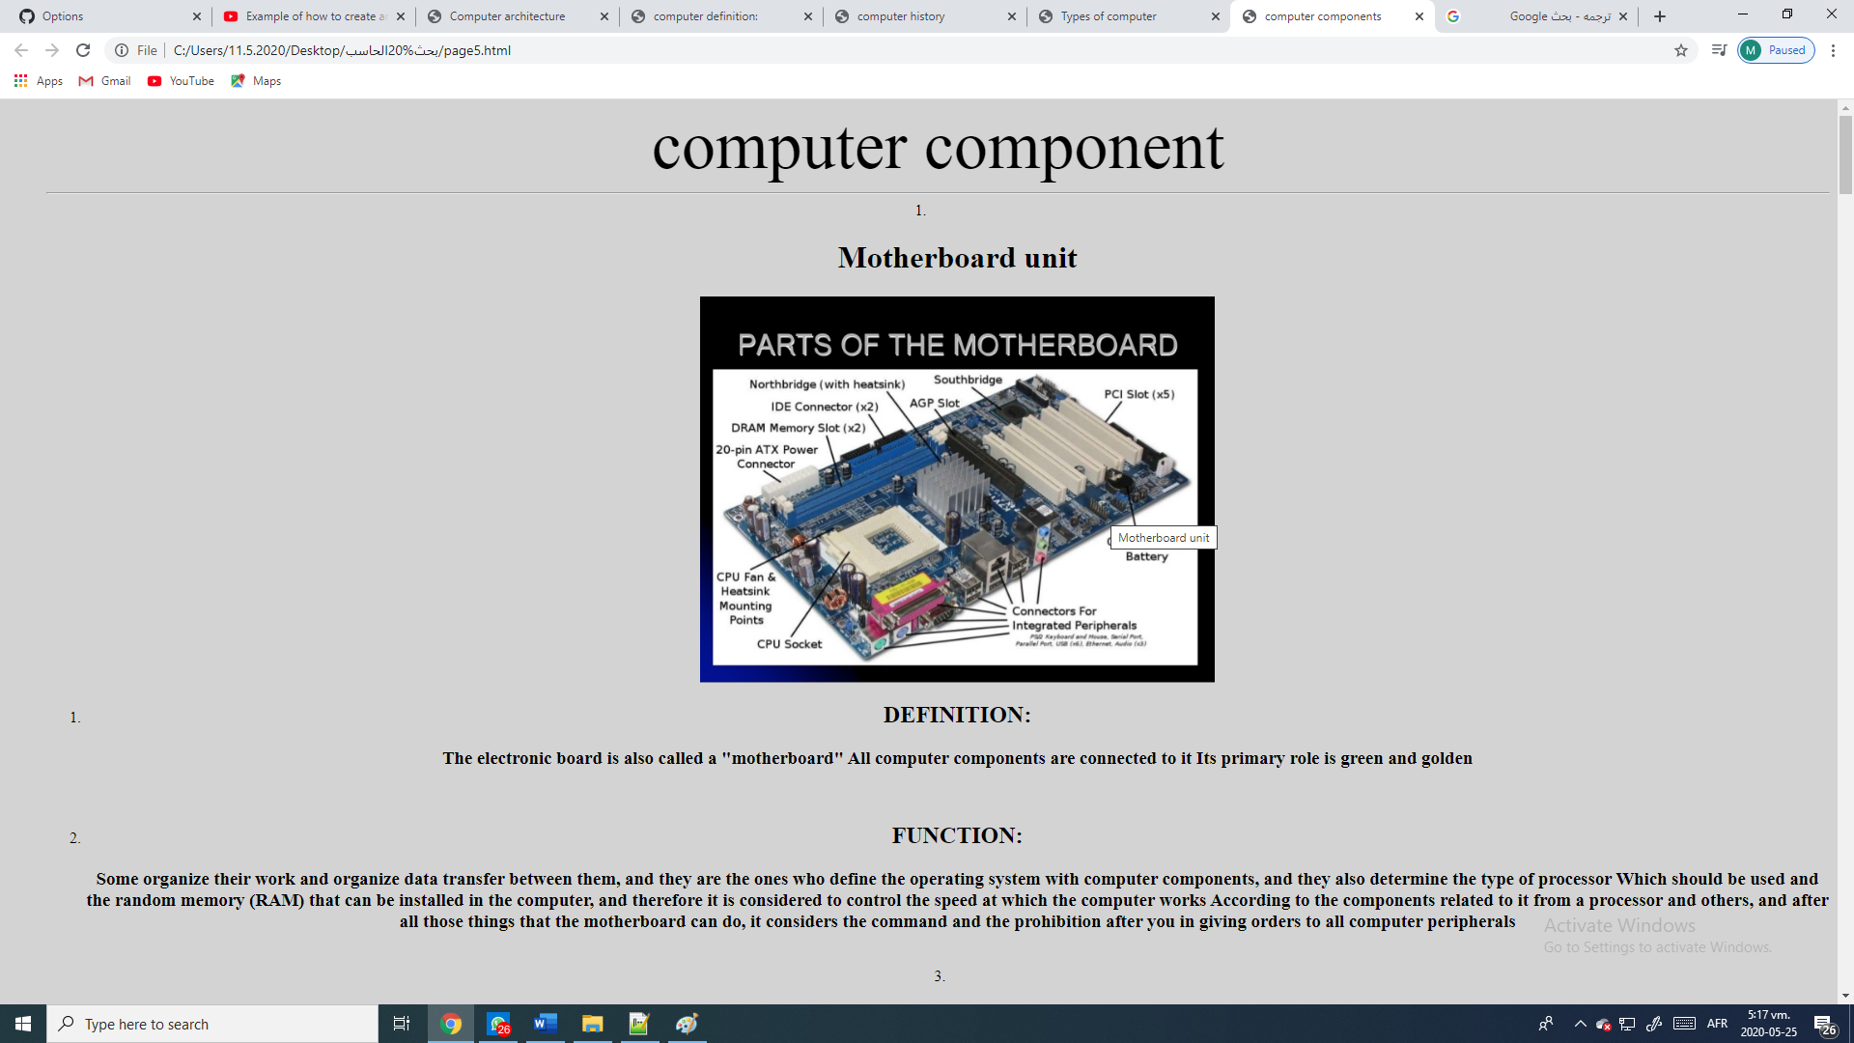 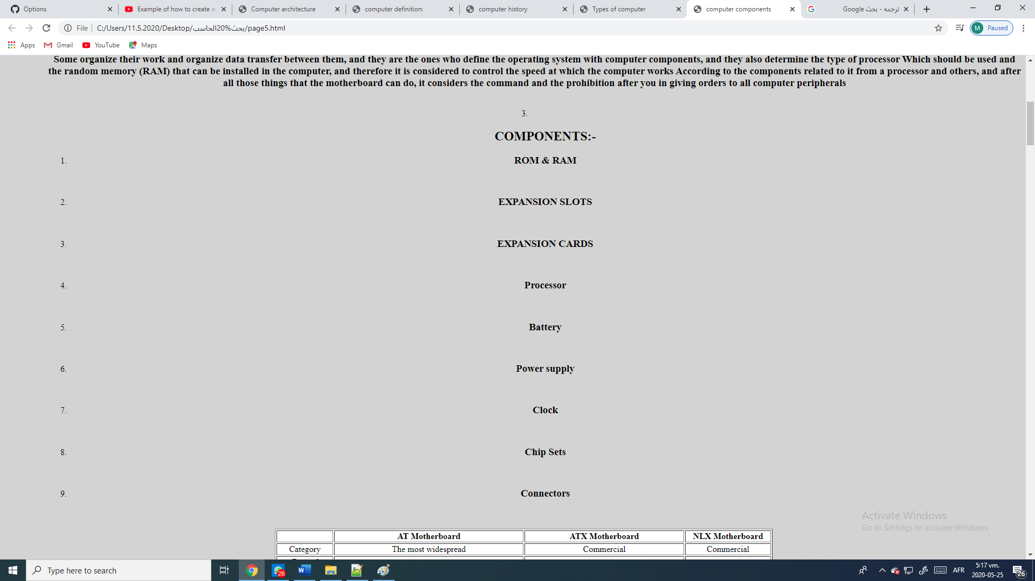 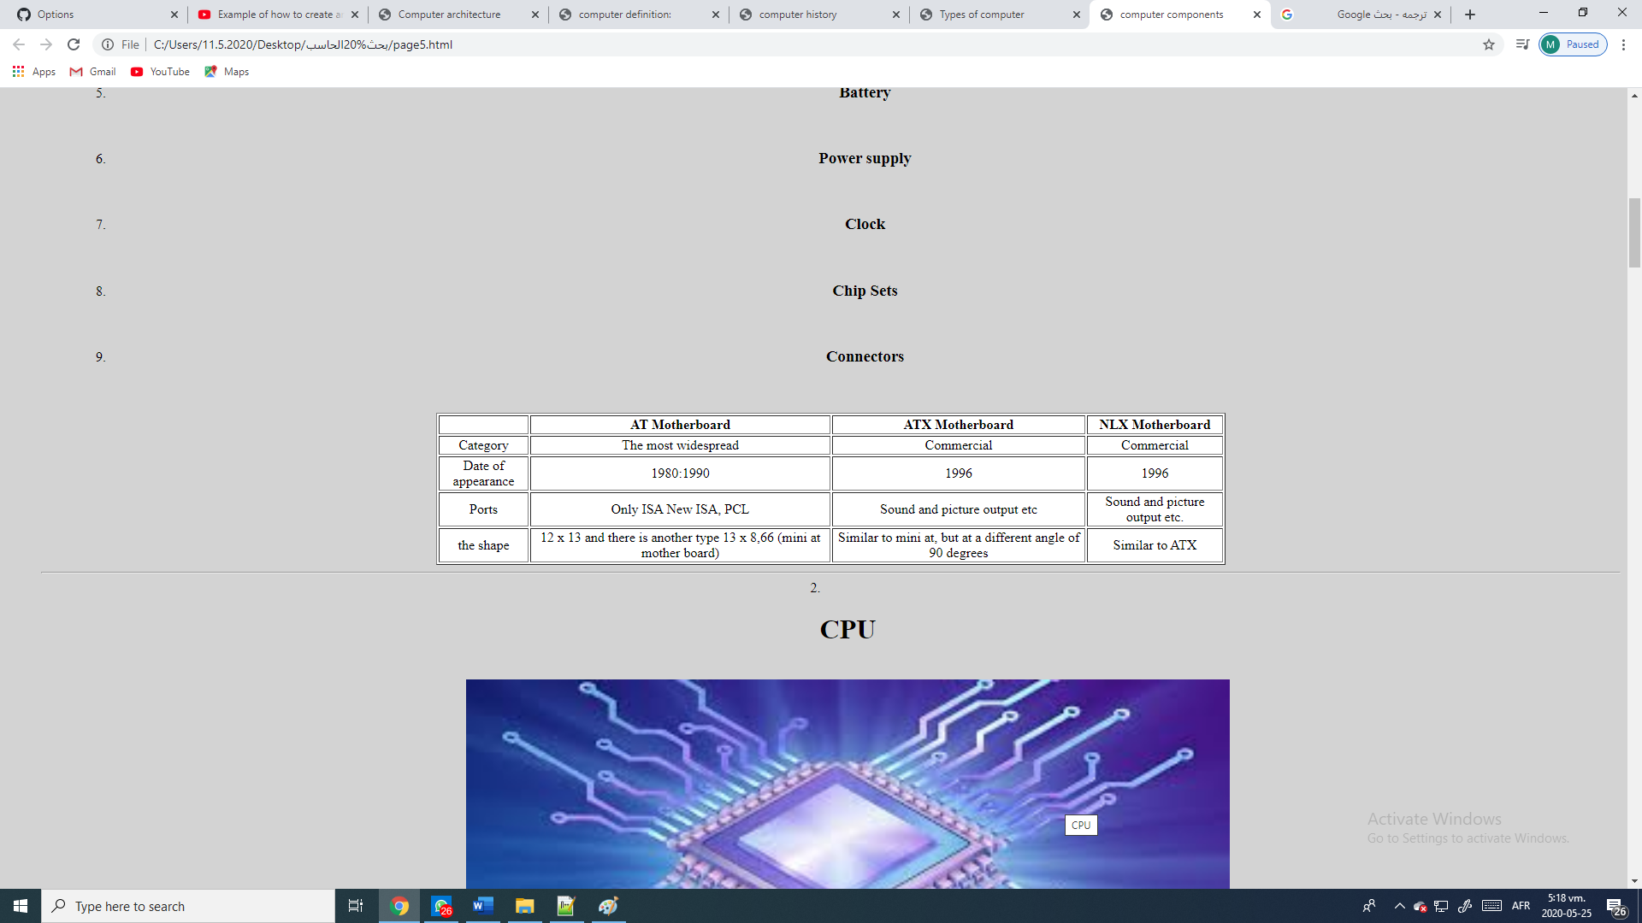 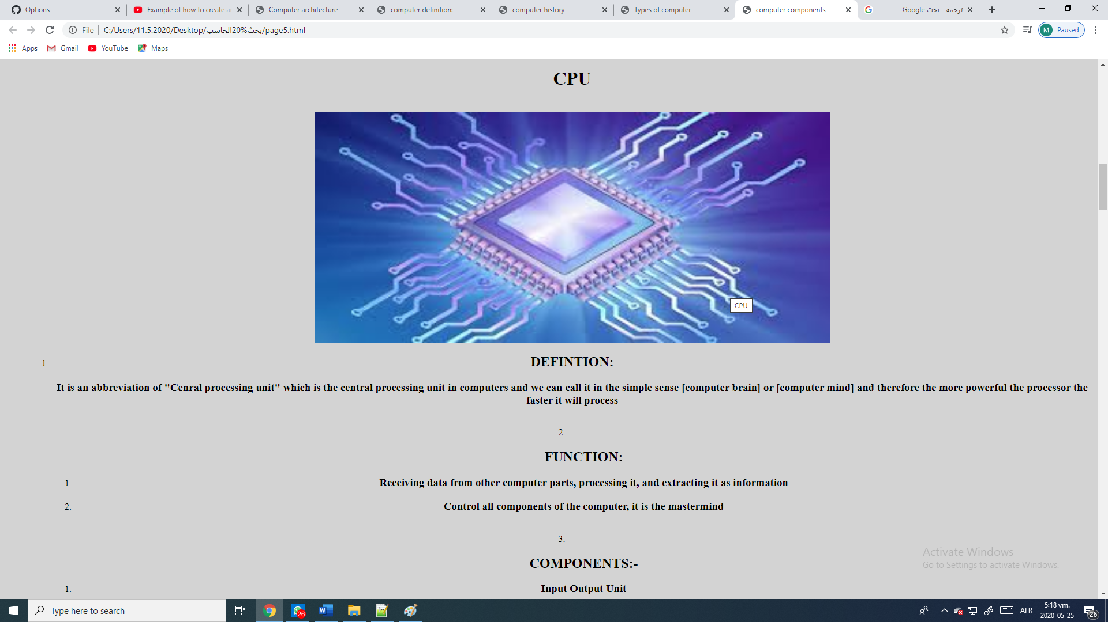 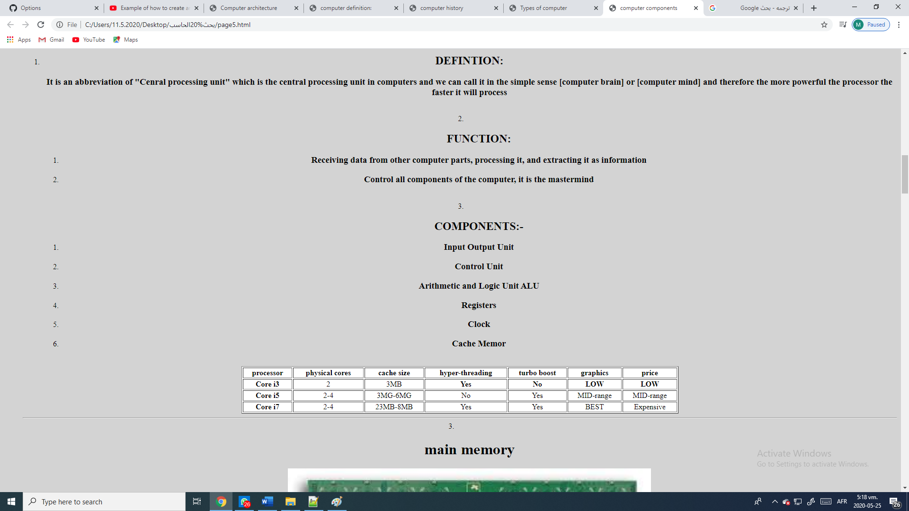 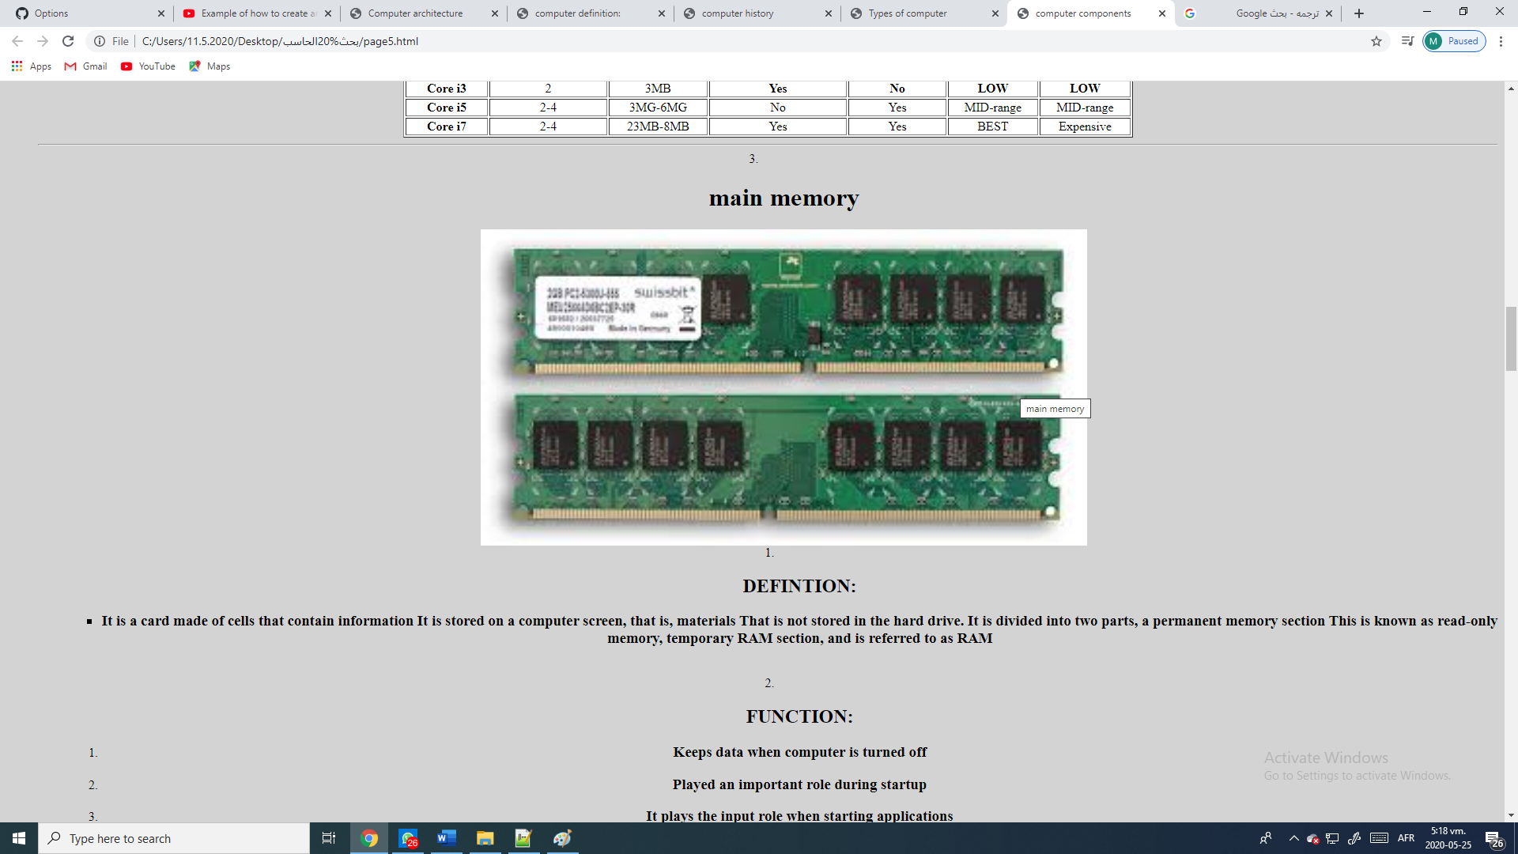 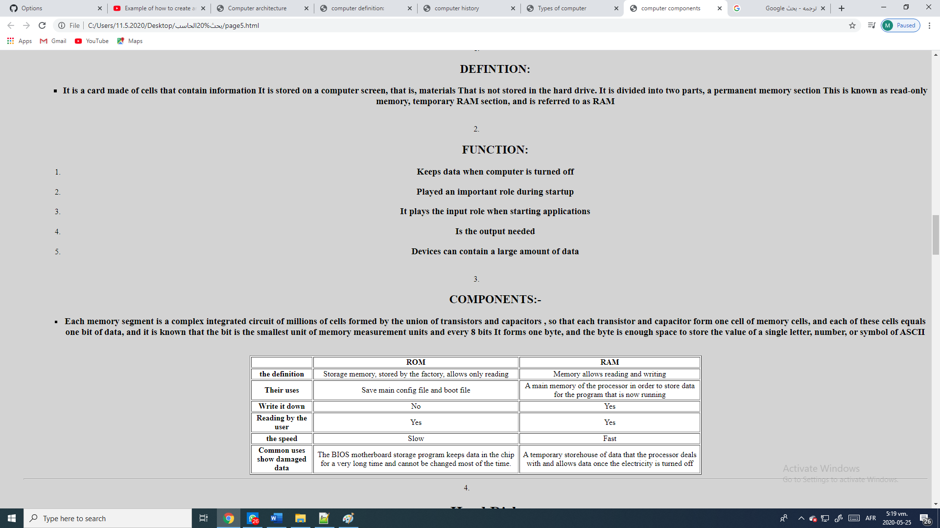 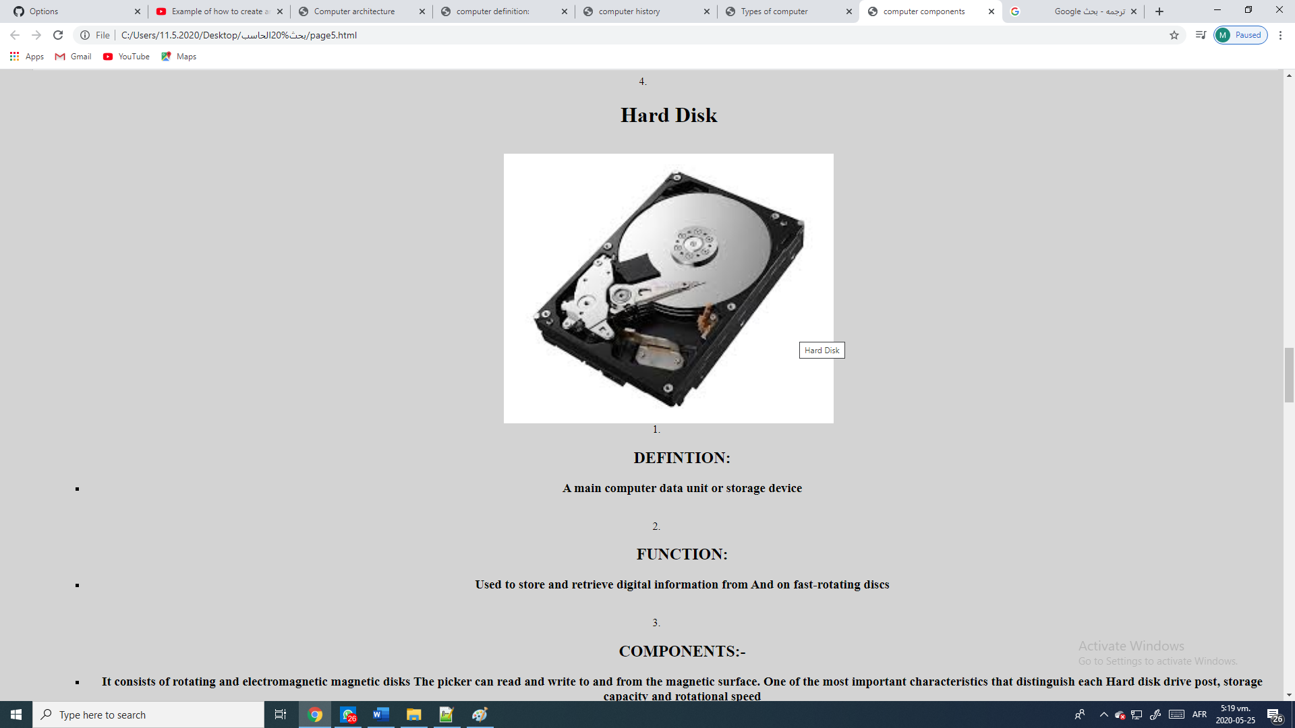 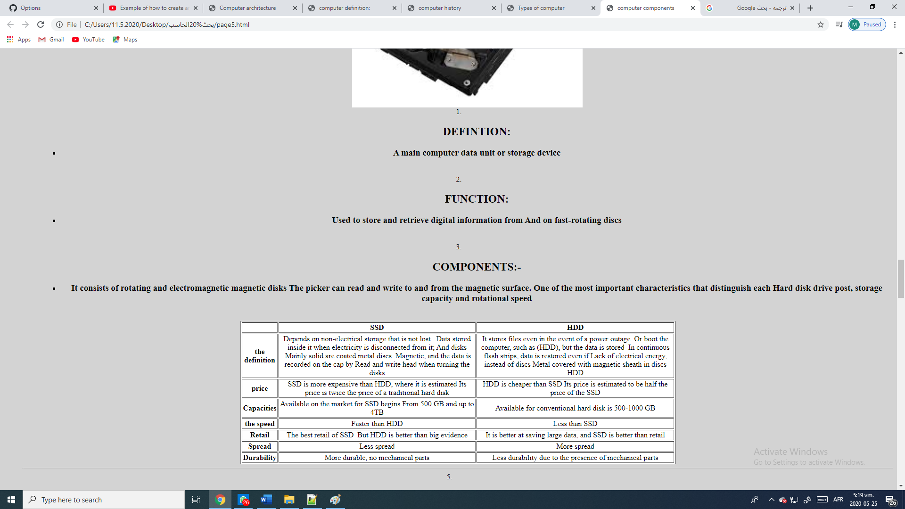 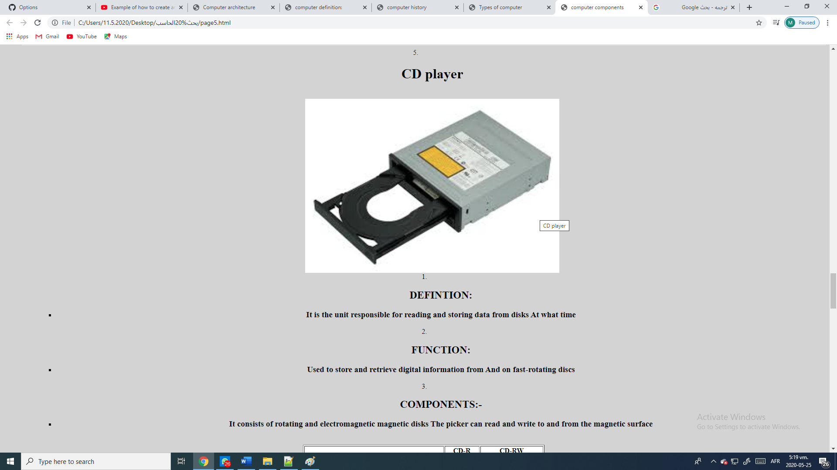 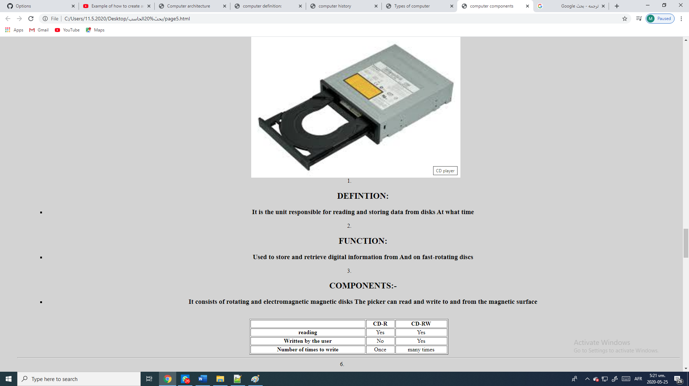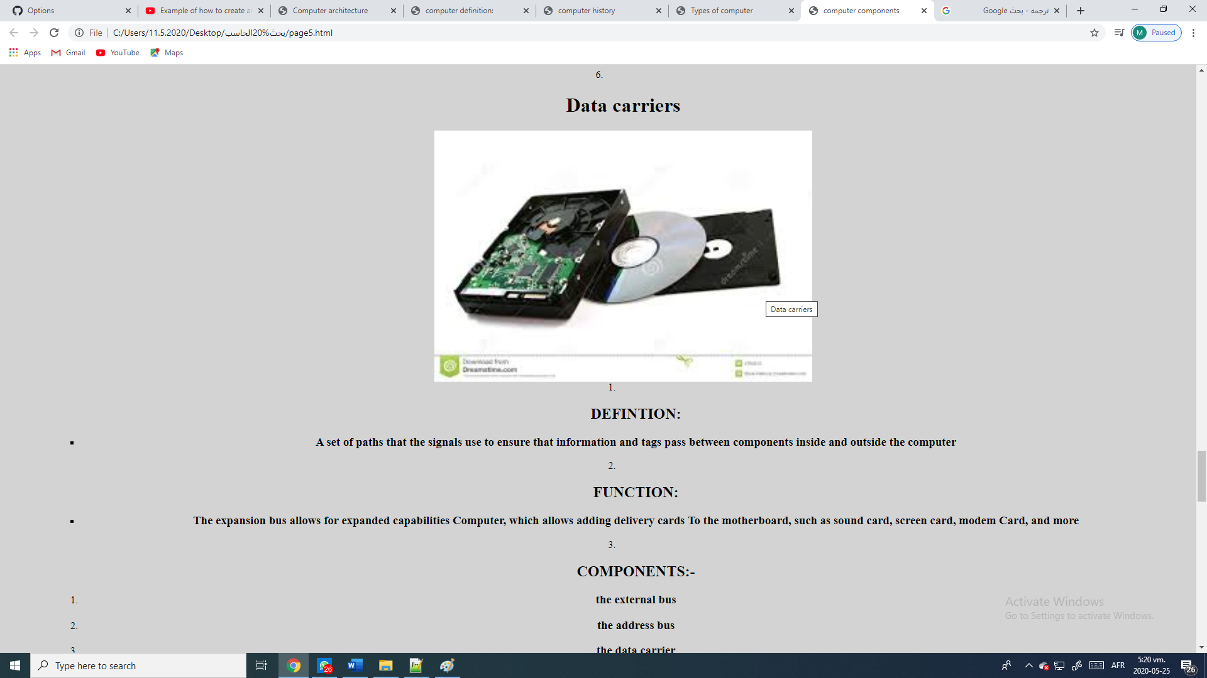 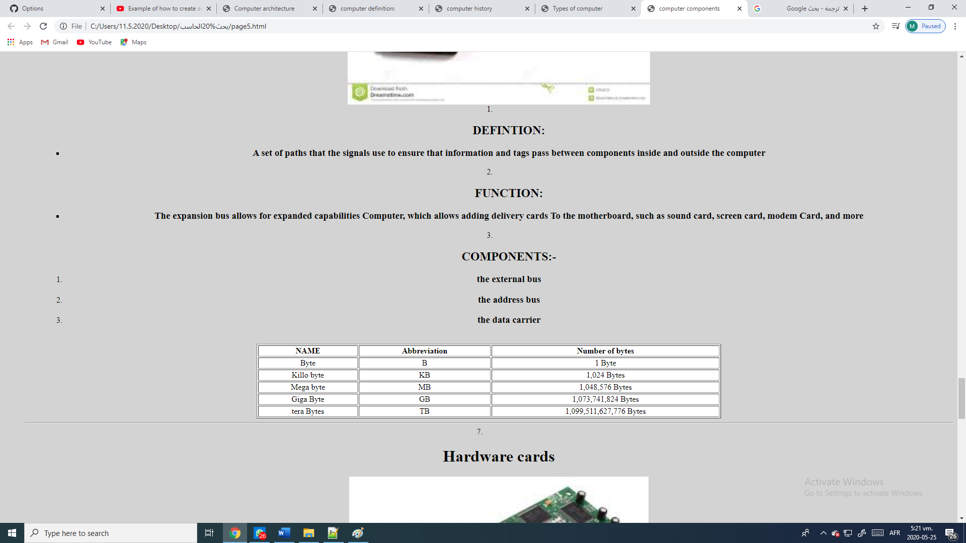 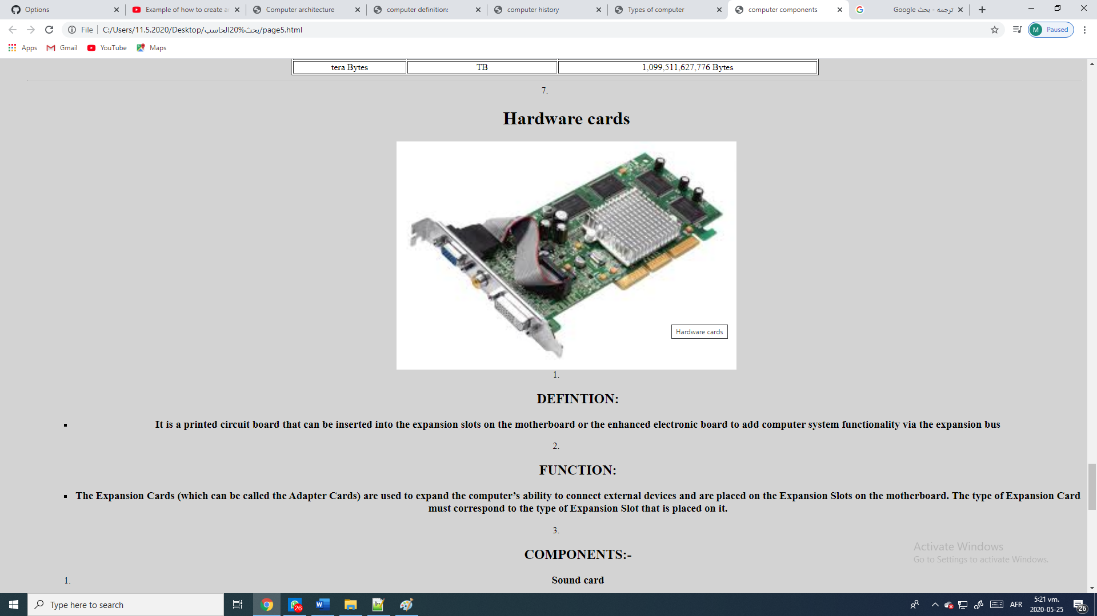 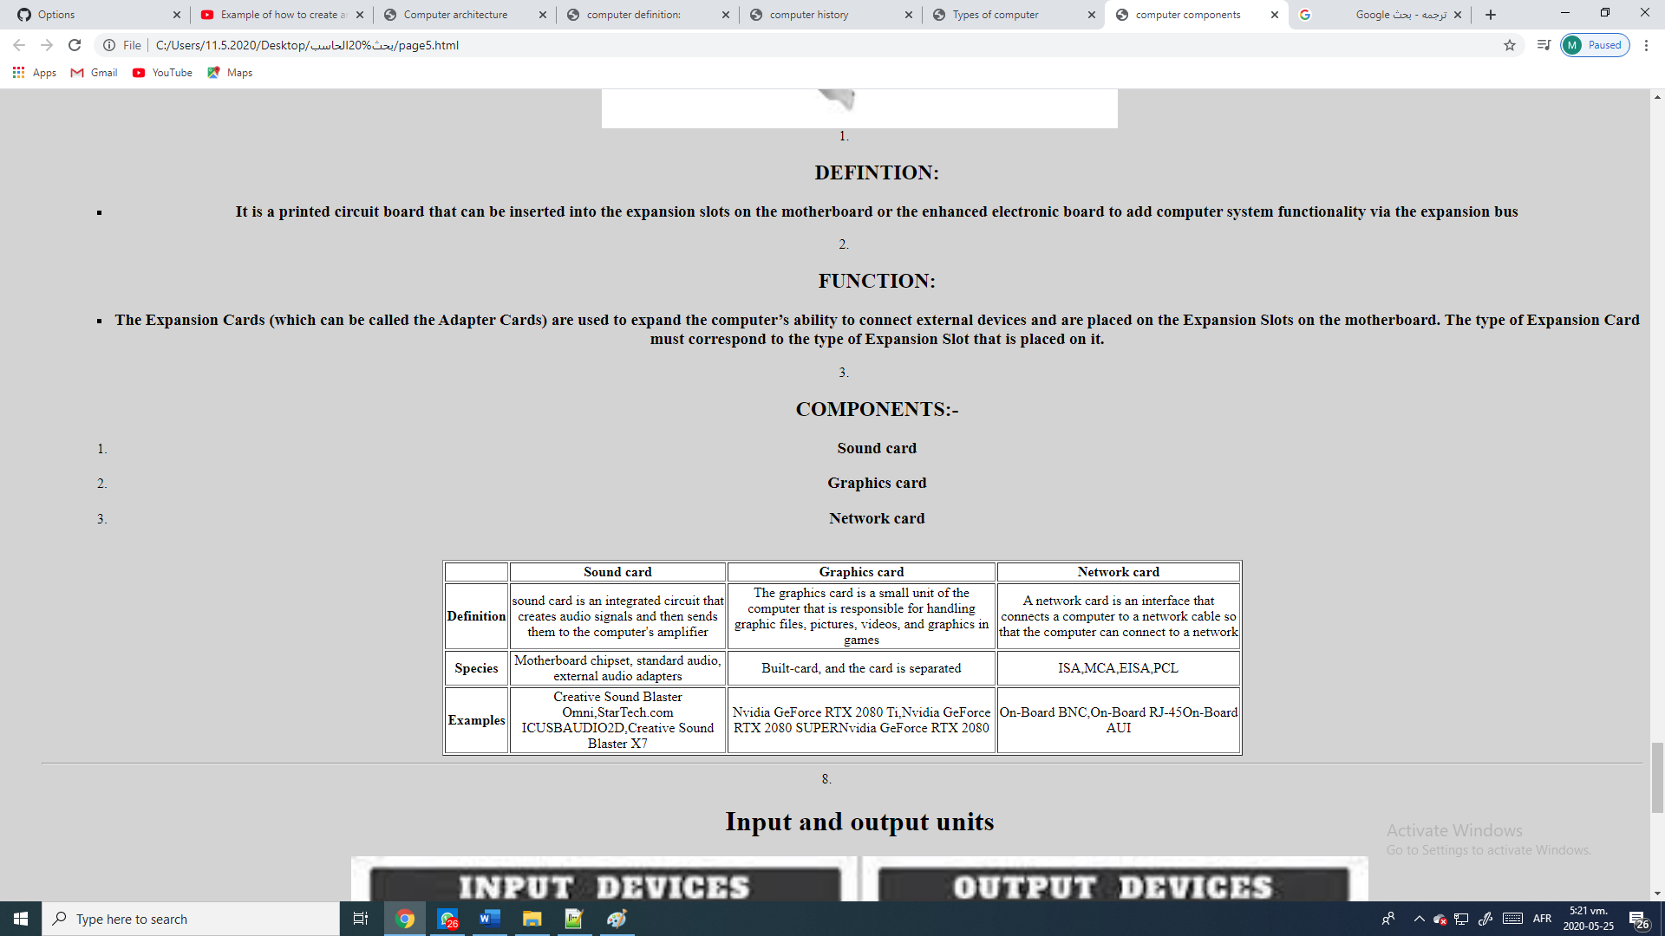 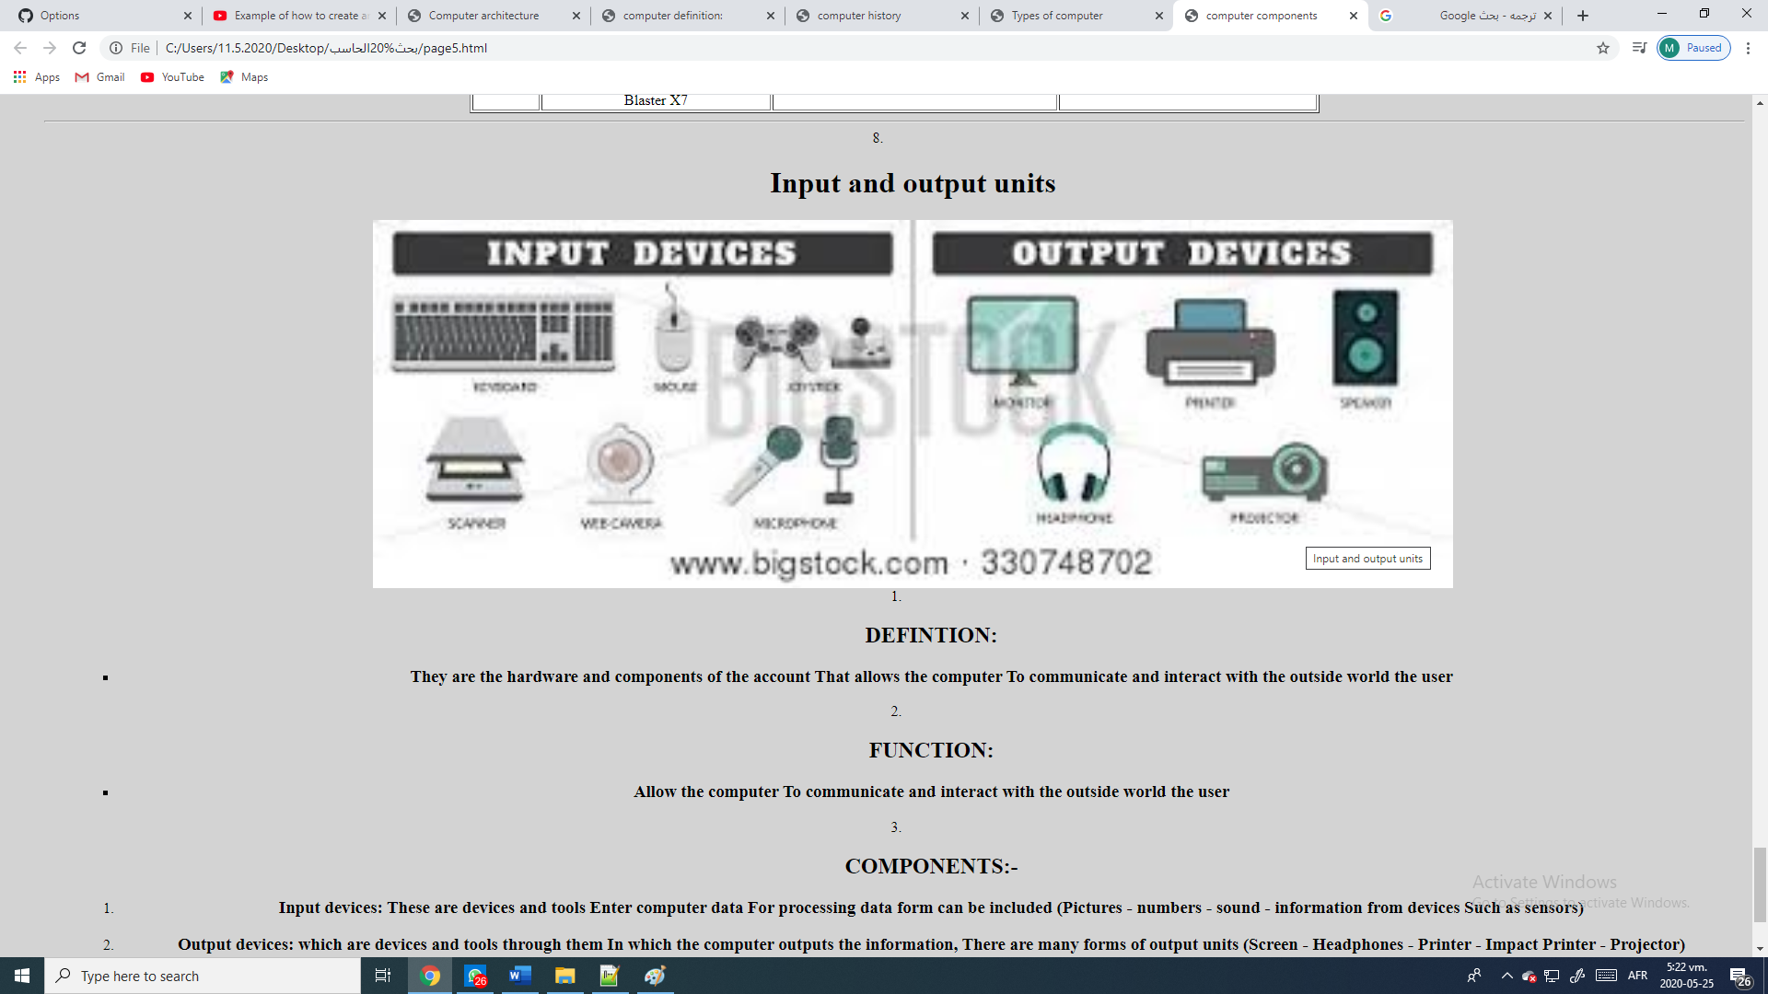 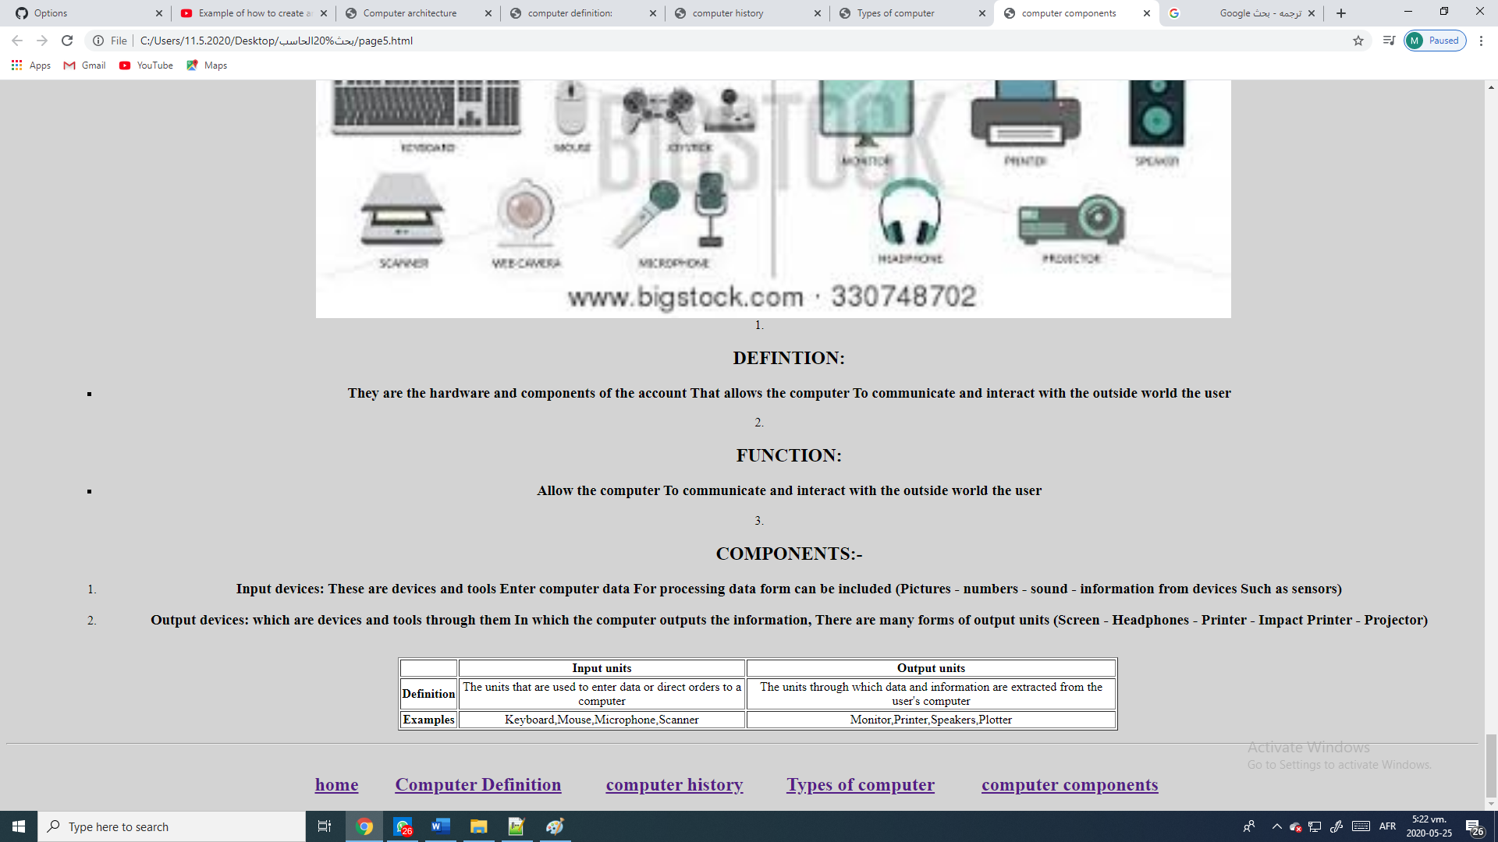

Source code:- 